Assignment 1: Anatomy of a Web Connection: A Brief Analysis

Featuring *THE HOST* (2013)

Author: Anthony dos Santos Pereira

Date: 03/04/2021



**Index**

0. INTRODUCTORY NOTE ………………………………………………………….……….………………………………. 2

1. ABSTRACT …………………………………………………………………………………………………………………...... 2

2. FRAMEWORK …………………………………………………………………………………………………………………. 2

3. TRACEROUTE ……………………………………………………………………………………………………………….... 3

3.1 WHAT IS TRACEROUTE? ………………………………………………………………………………… 3

3.2 TRACEROUTE COMMAND EXECUTIONS ………………………………………………………… 3

3.3 TRACEROUTE RESULT INTERPRETATIONS …………………………………………………….… 4

4. BUSINESS MODEL OF A WEB CONNECTION …………………………………………………………………….. 10

5. CONCLUSION: IMPLICATIONS OF THE INTERNET …………………………………………………………….. 10

5.1 SOCIAL IMPLICATIONS ……………………………………………………………………………………. 10

5.2 ECONOMIC IMPLICATIONS ……………………………………………………………………………... 12

6. REFERENCES ………………………………………………………………………………………………………………………………….. 12

Appendix 1. Traceroute within My Network ………………………………………………………………………………………. 14

Appendix 2. Traceroute within UA Network ……………………………………………………………………………………….. 15

Introductory Note

This document is the first assignment of the *Aspetos Profissionais e Sociais da Engenharia Informática* course unit and seeks to provide a plausible identification of the technologies, processes, actors and business models involved in a web connection and point out possible social and economic implications associated with the identified technologies.

Abstract

The Internet appeared for the first time in 1969 and today it’s completely embedded in our lives.

Traceroute is a command used to check network issues by sending data packets to the Internet and waiting that these will again be sent to the user network when a new hop has been discovered.

The traceroute results change for different locations.

For the same user network, if he tests the traceroute command at different hours, he will usually have similar results.

There are plenty of social and economic implications that result from a web connection, such as the concept of “global village”, increase of employment and the use of online services to satisfy individual needs.

Framework

According to the sociologist Manuel Castells, who wrote the book *The Internet Galaxy*, the Internet appeared in 1969, during the first experience of a node to node communication between two computers, through ARPANET, a computer network developed by ARPA [1]. The word sent in the experiment was "LOGIN", and although it was a failed experiment, as only the first two letters were sent to the second computer [2], this turned out to be a milestone towards the Internet as we know it today.

These days, the Internet is present in everything people do – a lot of things happen “beyond the wall” so that anyone can see their requests being solved when browsing on the Internet, such as technologies, processes and actors. All of these can lead to major changes in society.

What is traceroute?

Traceroute is a command used to know the path of data packets sent by a local network user as they travel all over the internet until they reach a destination. Think about the internet as a big set of networks that are interconnected with the use of multiple routers that track the packet traffic between computers and servers all over the world. With this in mind, it’s pretty clear that a packet does not travel from a point to another directly, passing through different networks and, implicitly, different routers [3].

Traceroute command is more complex than the ping one – while *ping* only pings the final destination, traceroute not only pings the final destination, but it also pings each router on its way to the final destination [4]; the computer sends three data packets to all routers they pass, and they send back these packets, allowing to obtain DNS domains and measure the round trip time that these took to and from each router. Note that traceroute is based on TTL mechanism: data packets are sent with a related value, and this value is decremented when they reach a router, reaching zero when they discover a new “checkpoint” (a new router).

With all of this said, traceroute can be a great tool to help discover network issues when it is not possible to establish a communication with a given IP address or domain [5].

Traceroute command executions

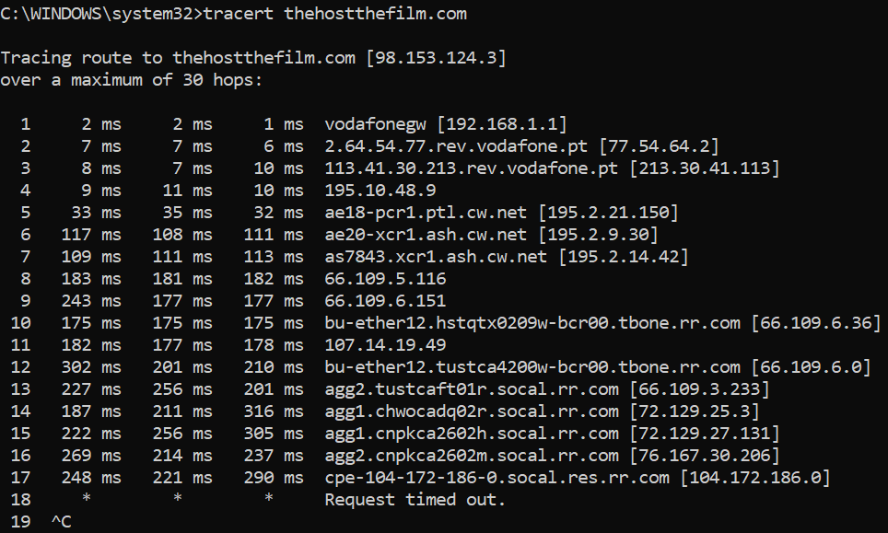

Fig.1 – Example of usage of the tracert command within Anthony’s network

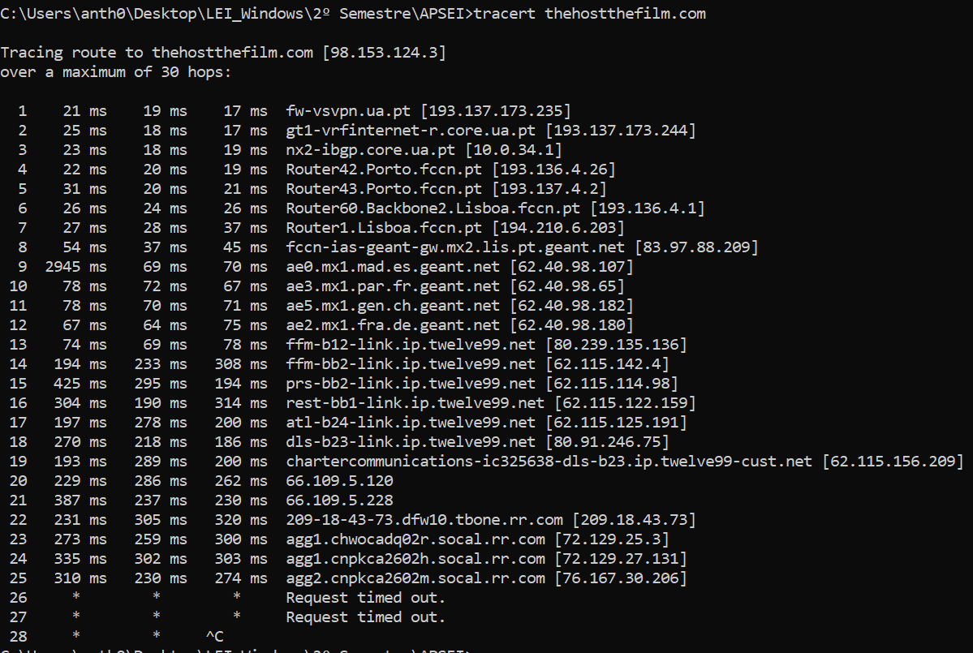

Fig. 2 – Example of usage of the tracert command within UA’s network

Traceroute result interpretations

As shown by the screenshots above, the location of a user interferes with the traceroute results, for instance, by changing the initial IPs and domains. This happens because the user was in different LANS, so the path that each data packet chose to reach its destination has changed.

It was also concluded that, for a specific location and LAN, the traceroute results are mostly the same (with an exception, explained in the next paragraph). This may be due to the fact that the path has the least cost for the establishment of the communication and, assuming that the Internet is redundant and that several paths will lead to the same destination, it’s likely that the network is not overloaded, always privileging the same path.

Both inside and outside the university’s network, it was never possible to complete the traceroute research - the last hops always have the “request timed out” message and there is no hop with the IP that’s used as a parameter for the traceroute command. Most of the time, the last shown IP is 76.167.30.206 (check the screenshot above), but sometimes there is a new one – 104.172.186.0. Pay attention because we’ll come back to this later.

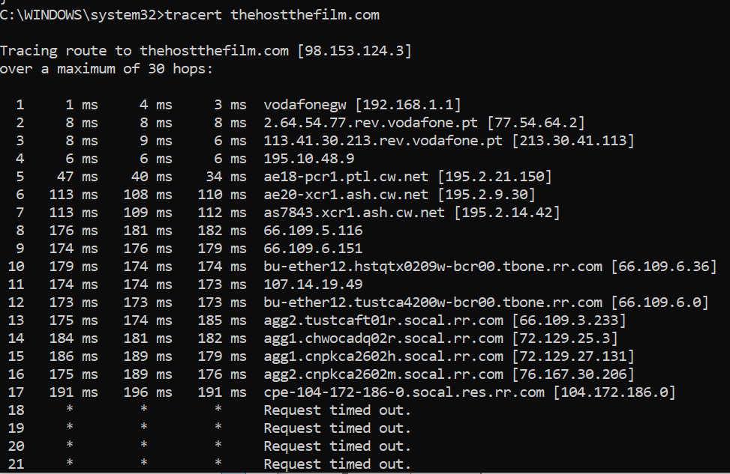

Fig.3 – Traceroute with a new last shown IP.

To help the process of analysing the results obtained while testing the traceroute command, an IP geolocation API was used – ipinfo.io. Using the curl command together with ipinfo and the IP to be analyzed, it was possible to retrieve a JSON with additional information related to that IP:

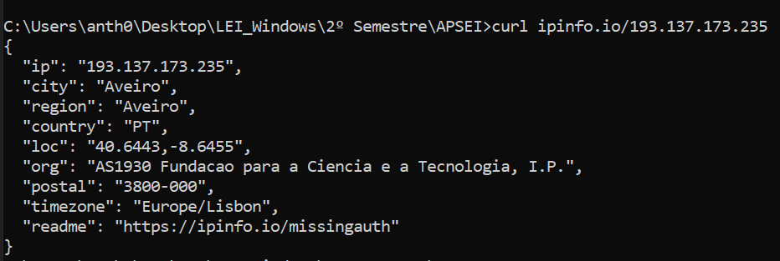

Fig.4 – Example of usage of the IP geolocation API ipinfo.io [6]

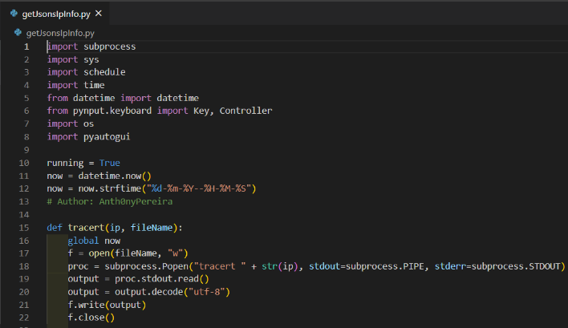 With this in mind, a python program was made to help to save the traceroute command results and get all the JSONs for each of the IPs – this program accepts two arguments, the website that’s being inspected and a university account password:



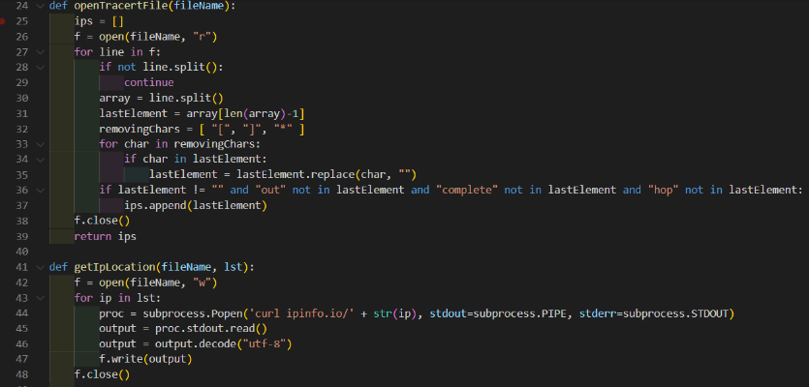

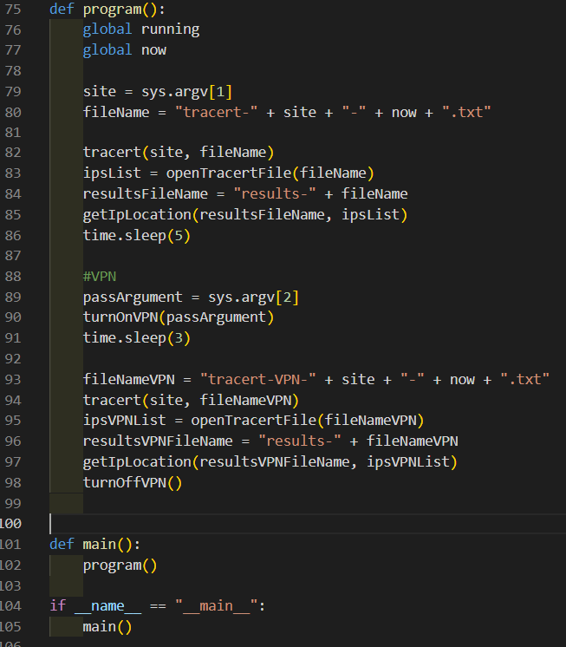

Fig.5 – Python program to obtain a sequence of JSONs using an IP geolocation API

With the results that were achieved, two diagrams were made to help visualize the way that these data packets perform during the traceroute command (CN means “changed network[1]”):

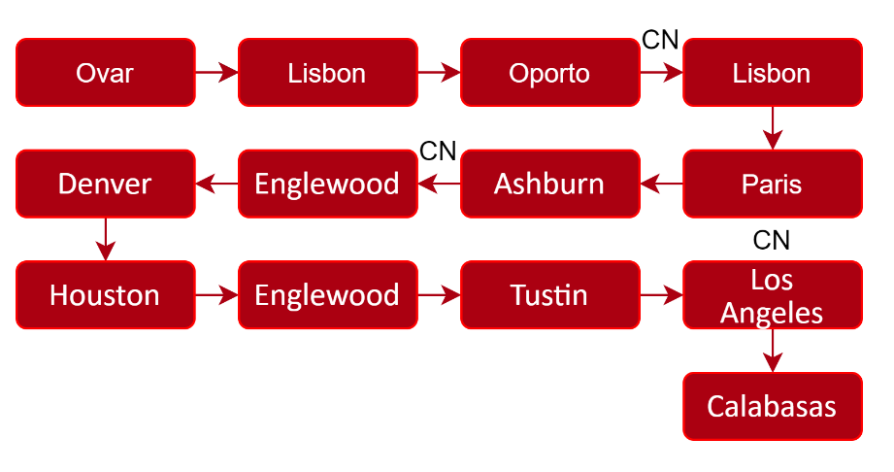

Diag.1 – Path traced with VPN switched off

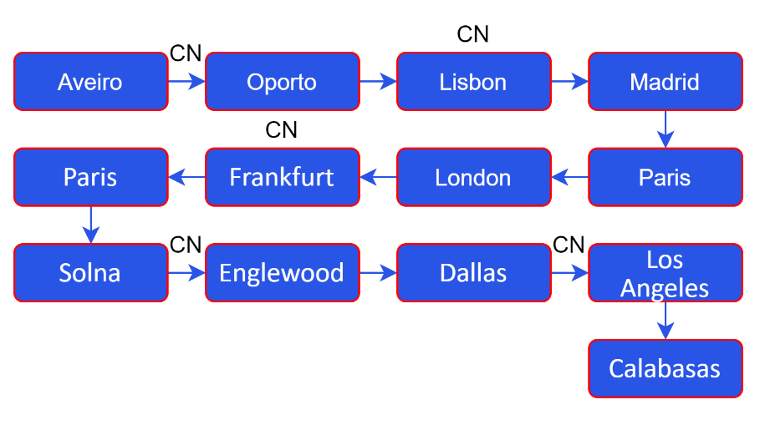

Diag.2 – Path traced with VPN switched on

Some cities are out of place or have changed (check Tustin and Dallas, for example), so, it’s reliable to say (again) that the path changed in these two different situations. Checking the two tables (see the appendix), it can be observed that even the organizations have changed too, even after the university’s network. So, we can assume that the tracert path is not always the same and that it’s dependent on the location where the user is, leading to a possible mid-different path/networks – not only the user’s network can (obviously) change, everything can change.

Now that the location of the IPs was recorded, let’s go back a little bit and check the location of both IPs 76.167.30.206 and 104.172.186.0:

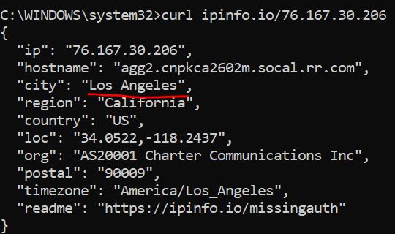 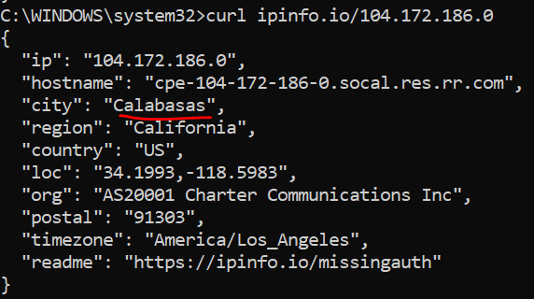

Figs.6 & 7 – Results of the consultation of the geolocation API for two specific IPs

The target IP 98.153.124.3 was also inspected:

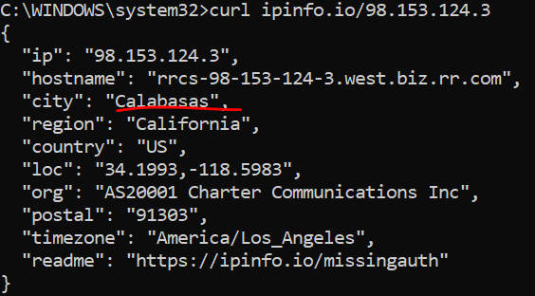

Fig.8 – Result of the consultation of the geolocation API for the target IP

All three IPs are from the same organization’s network and region – California. 104.172.186.0 and 98.153.124.3 (the IP that sometimes appears in the trace and the initial IP, respectively) are from the same city – Calabasas!

Now, let’s check the distance between Los Angeles and Calabasas:

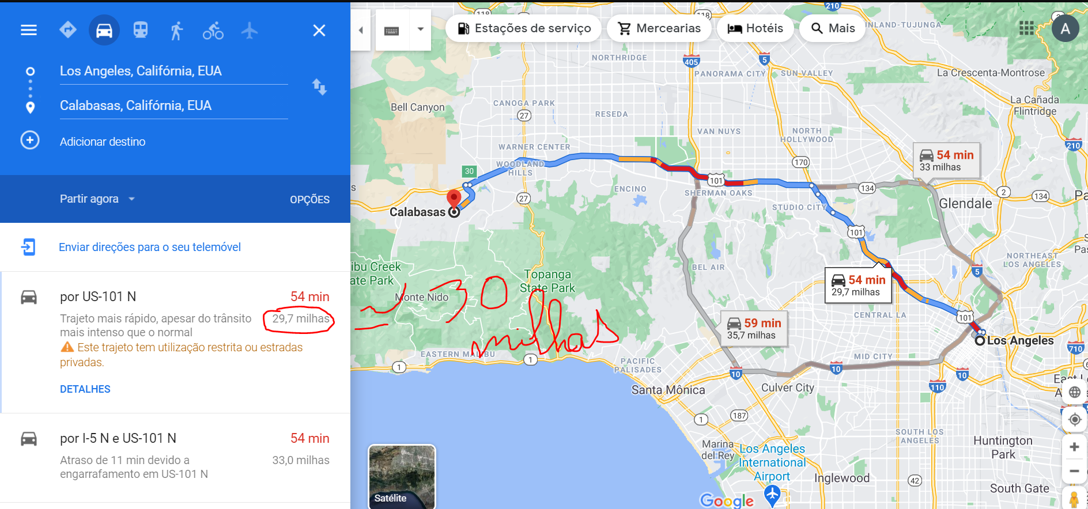

Fig. 9 – Distance between Los Angeles and Calabasas, using Google Maps

Time to make a conversion:

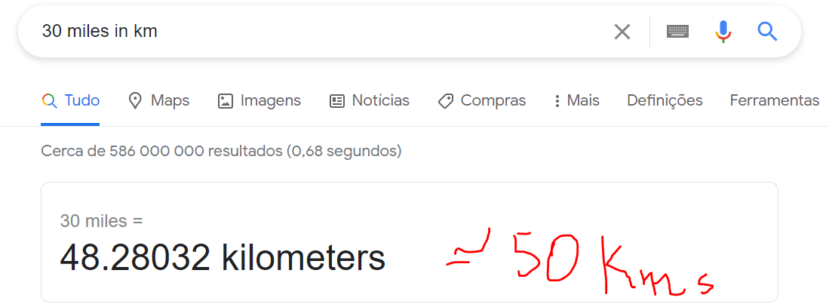

Fig.10 – Conversion between miles and kilometers, using Google

With all of this shown, it can be deduced that the server is probably denying any interaction with the user, that is, it’s not responding with the traceroute packages that were sent to it. Both possible last IPs are close to the real location of the server - either they are from the same city or are 50 km apart from each other - so it’s safe to discard the possibility of 98.153.124.3 being too far away from 76.167.30.206 that they are not able to connect to each other. Another thing is that all three IPs are from the same network, so, we can surely say that the problem is not the inability to connect to a new ISP’s network[2].

A quick search was performed and a curious result was gotten:

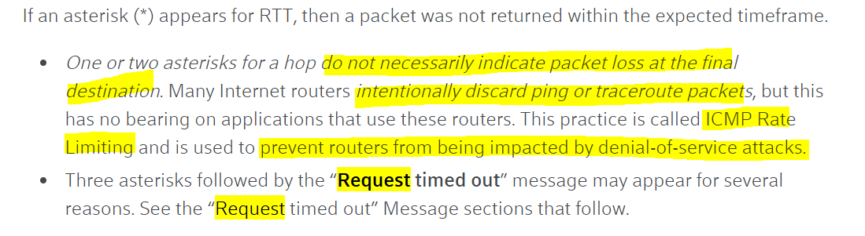

Fig.11 – Paragraph from the website Xfinity.com

It seems that some routers can intentionally discard traceroute packets because of security reasons, such as preventing DoS attacks [7] using a firewall. This could be what’s happening in this case. Let’s check the *ping* command:

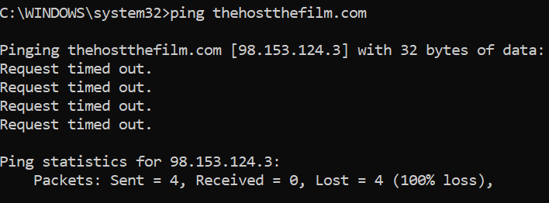

Fig.12 – Result of a *ping* command to the same destination IP, confirming the previous hypothesis

Another reason that sustains this assumption is the fact that the website seems forgotten by everyone:



Fig.13 – Homepage of the website The Host, a movie from the year 2013

As we can see from the screenshot taken, some things seem misconfigured (some raw code appears) and even if we check some features that it offers (or that it once offered), we can see that there are some bugs or some features that no longer exist. Thus, it’s possible to assume that this website is no longer maintained – which can lead to security problems. So, the owners could probably block some ways to communicate with the internet – to protect what’s left.

Business Model of a Web Connection

- Clients

The clients would be the users of a specific ISP that allows them to access the Internet (such as me and Vodafone) or the ISPs themselves that are successively incorporated into larger networks

- Partners and Competitors

The multiple ISPs would have partnerships with hardware companies that provide the necessary material for building the network and with other ISPs. An example is FCT – *Fundação para a Ciência e Tecnologia* – that has a partnership with *Géant*:



Fig.14 – Screenshot from geant.org showing a partner with FCT [8]

The competitors of ISPs would be other ISPs, such as ISPs from the same country (such as *NOS* and *MEO*) or others. There’s an article on the Internet that shows that *Reliance Jio* made a big partnership with several other companies, such as *Tesla Company*, to compete against *Vodafone*:

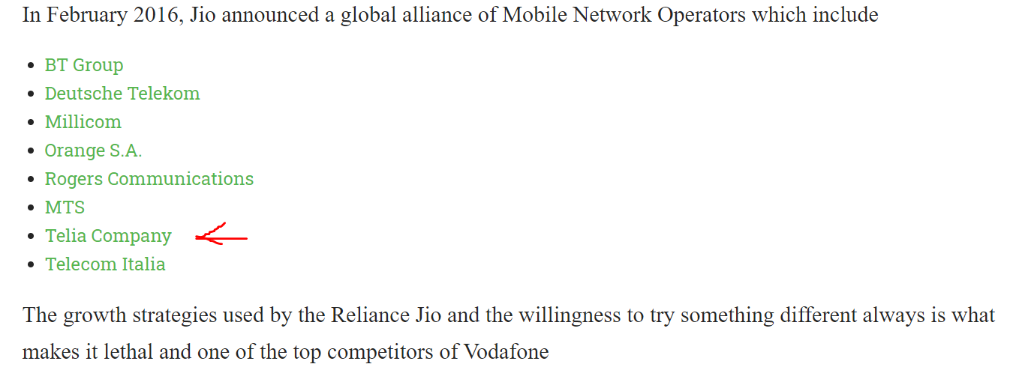

Fig.15 - Extract from an article showing Vodafone competitors [9]

- Who benefits the most and who does not

Those who benefit the most are the common Internet users that start to benefit from a service and the company that provides it. The ISPs that won’t be able to captivate consumers would not take any benefit.

Social implications of the Internet

It’s clear that the ability to connect to a large universe of interconnected networks, which we call the Internet, has allowed us to feel “less alone” - it is easier to communicate with a family member who is far away, you’re able to watch in real-time a ceremony in a country thousands of kilometers away without having to be there physically and can learn about news or events from countries on the other side of the world. We are increasingly becoming a “global village” - a concept introduced by Canadian Herbert Marshall McLuhan that seeks to explain the relationship between new communication technologies and the idea that by shortening figuratively the distance between all human beings that inhabit, we are all in a village in which we know each other and know everything that goes on all over the world. Just think about it: how could we send an e-mail to our boss or a message via Messenger or WhatsApp to a friend without a web connection?

The access to the internet also allowed public figures to show their authority beyond television, using social media or blogs, or to become public figures through their constant presence in these same social networks and/or blogs: let’s remember Kim Kardashian, who after having participated in a reality show about her family, started to publish her personal life experiences on her social networks, taking the opportunity to advertise her own brands of perfumes, makeup, partnerships with magazines and clothing brands, etc [10]. Now, let’s talk about Ana Garcia Martins, better known as “A Pipoca Mais Doce” – she is the owner of a blog with the same name that was created in 2004 and a pioneer in this type of technologies, which made her famous by having the most visited blog ever in Portugal [11]. A better-known example - Justin Bieber, singer, composer and actor quite acclaimed nowadays that started posting covers on Youtube in 2007 and then he was found by Scooter Braun, becoming his agent, and signed a professional contract with Island Records two years later, beginning his artistic career [12]. To finish this topic, another example: Mário Daniel, the famous Portuguese illusionist who was also a presenter on the SIC television program, “Minutos Mágicos”, is a recurring presence on Facebook, in which he shares articles and gives his opinion about covid-19 - recommending what people should and shouldn't do.

However, access to the internet has also created even more social inequalities, as not everyone has the chance to access this service equally - in third-world countries, this is still not a very common reality. Thus, it can be said that this social inequality is also related to the existing economic inequalities, in the country and the world. If there are no resources to end hunger in Africa, no resources to end all homeless people who roam the cities and suburbs of Oporto and Lisbon, how would it be possible to guarantee equal access to the internet?

Another negative implication inherent in the possibility of a web is how quickly online news are spread. We live in an era in which it’s increasingly common to view fake news on current topics that are not yet consensual (unfortunately) and that incite violence and hatred. This is the case with issues related to the LGBTQ + community and covid-19. The internet also promotes the spread of catastrophic news, such as accidents, homicides, bombings, wars, promoting a feeling of insecurity and creating the idea that the world was once safer. My grandmother says that "when I was little, we could leave the door open that no one would bother us". This thought may be slightly distorted from reality – probably the rate of incidents has not changed significantly over time, but taking into account that it’s possible for us to know more quickly and more often what’s happening in the world, this can create a false sense of insecurity and panic.

Economic implications of the Internet

There would be no Internet without hardware and its constant maintenance and improvement of the communications and materials for transporting the data packets such as optical fibers, or even without the implementation of security mechanisms, among others. Therefore, it’s clear that the existence of the internet has created more jobs associated with areas of computer engineering as networks, electronics and security, as well as engineering in general.

But in addition to the job offer and growth of companies provided by the existence and maintenance of the Internet, it also allowed the emergence of telework, currently so important in times of a pandemic - this is the case of companies like Ubiwhere and clothing stores that, today, advertise their products in lives on the Internet.

The Internet also brought a new set of features, providing goods and services without the customer having to leave home. This is the case with online stores, such as Fnac, Amazon and Continente that allow a quick purchase of goods, health services such as online consultations in general medicine or psychology, bank transfers through services such as Paypal and MB WAY, streaming services such as Netflix, YouTube and Spotify, allowing to watch movies without having to go to a cinema and listen to music without having to attend a concert. Regarding streaming services, there are even partnerships with companies to display advertisements, as is the case with YouTube and the free version of Spotify (in which every five songs heard, an ad is shown), emerging new forms of income. And talking about forms of income, thanks to these platforms YouTubers and Streamers came up – people who create content and publish on YouTube, being paid for it, and who create content about video games and show live matches, being equally paid, respectively. Again, the appearance of the Internet and the employment creation.

On the other hand, all these automated services present on the Internet can cause problems: one of them is to increase economic inequalities between companies - let's assume a local grocery store and a supermarket; if this last one creates an online platform to provide its services and reach a wider segment of customers, it will increasingly gain consumers who, satisfied with their value proposition and the ease in buying the goods they provide, they become regular customers, creating long-term revenue streams. And the grocery store? Most likely it’ll lose clients. Another possibility is that, when creating a digital platform, work post will decrease - assuming that a company that had a physical store with 100 employees creates an online store that, requiring less labour, passes needing only 20 employees. This will increase the unemployment rate.

References

|  |  |
| --- | --- |
| [1] | M. Pinto, “Como surgiu a Internet?,” [Online]. Available: https://pplware.sapo.pt/informacao/como-surgiu-a-internet. [Acedido em 28 03 2021]. |
| [2] | E. Andrews, “Who Invented the Internet?,” [Online]. Available: https://www.history.com/news/who-invented-the-internet. [Acedido em 28 03 2021]. |
| [3] | K. Bartley, “VoIP Troubleshooting: What Is Traceroute and How Does It Work?,” [Online]. Available: https://www.onsip.com/voip-resources/voip-fundamentals/voip-troubleshooting-what-is-traceroute-and-how-does-it-work. [Acedido em 23 03 2021]. |
| [4] | P. A. Videos, “Traceroute (tracert) Explained - Network Troubleshooting,” [Online]. Available: https://www.youtube.com/watch?v=up3bcBLZS74. [Acedido em 23 03 2021]. |
| [5] | SolarWinds MSP, “What Is Traceroute and How Does It Work?,” [Online]. Available: https://www.solarwindsmsp.com/blog/what-is-traceroute-how-does-it-work. [Acedido em 23 03 2021]. |
| [6] | B. Dowling, “IPinfo,” [Online]. Available: https://ipinfo.io. [Acedido em 23 03 2021]. |
| [7] | Xfinity, “Traceroute Command Overview,” [Online]. Available: https://www.xfinity.com/support/articles/run-traceroute-command. [Acedido em 25 03 2021]. |
| [8] | Géant, “Géant Project Partners,” [Online]. Available: https://www.geant.org/Projects/GEANT_Project_GN4/Pages/Partners.aspx. [Acedido em 01 04 2021]. |
| [9] | HeartOfCodes, “Competitors of Vodafone | Vodafone competitors,” [Online]. Available: http://heartofcodes.com/competitors-of-vodafone. [Acedido em 01 04 2021]. |
| [10] | M. Mayer, “A história completa de Kim Kardashian,” [Online]. Available: https://medium.com/@mtnMayer/a-hist%C3%B3ria-completa-de-kim-kardashian-bea7f7ae4f16. [Acedido em 28 03 2021]. |
| [11] | Wikipedia, “Ana Garcia Martins,” [Online]. Available: https://pt.wikipedia.org/wiki/Ana_Garcia_Martins. [Acedido em 28 03 2021]. |
| [12] | Wikipedia, “Justin Bieber,” [Online]. Available: https://pt.wikipedia.org/wiki/Justin_Bieber. [Acedido em 28 03 2021]. |
| [13] | J. Tyson, “How Internet Infrastructure Works,” [Online]. Available: https://web.stanford.edu/class/msande91si/www-spr04/readings/week1/Howstuffworks.htm. [Acedido em 29 03 2021]. |
| [14] | Ascenty, “NAP (Network Access Point): O que é ele e como pode te ajudar?,” [Online]. Available: https://www.ascenty.com/blog/artigos/nap-network-access-point. [Acedido em 29 03 2021]. |

Apendix 1. Traceroute within My Network

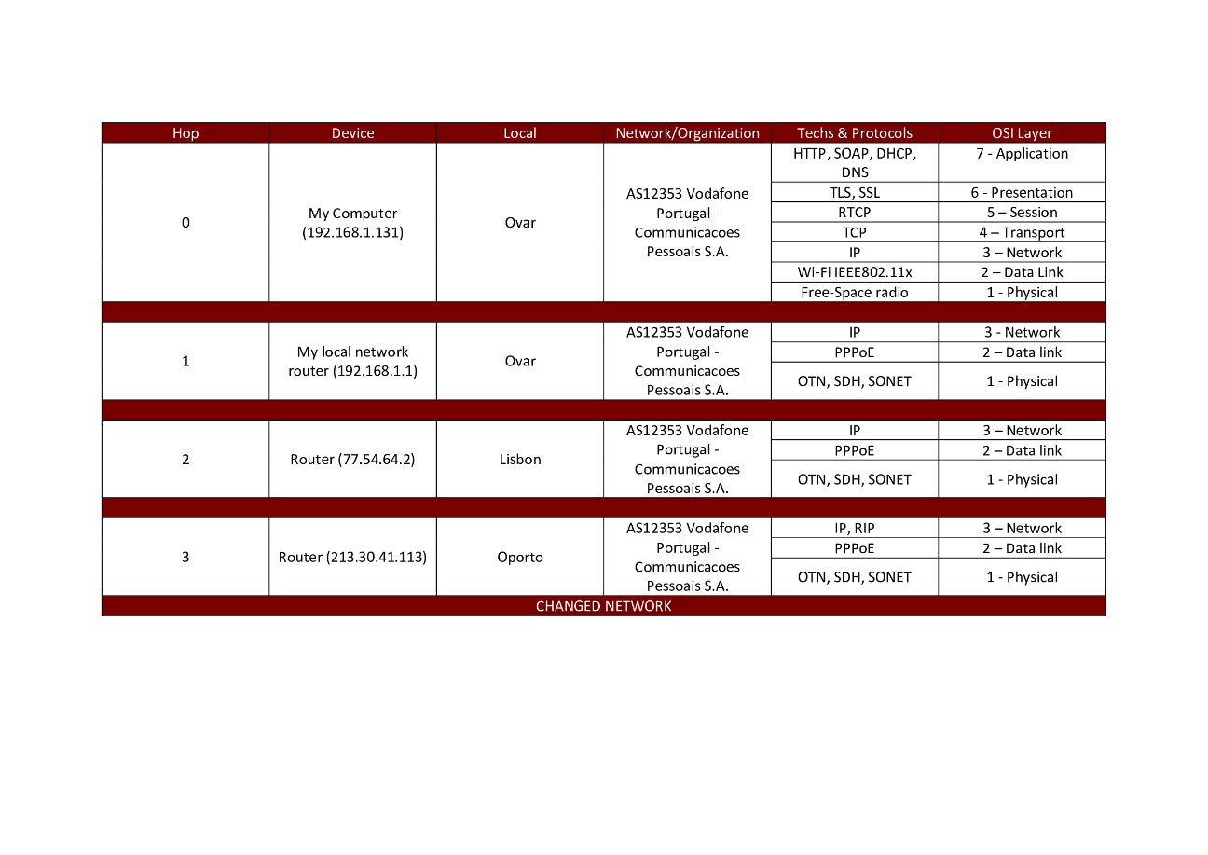

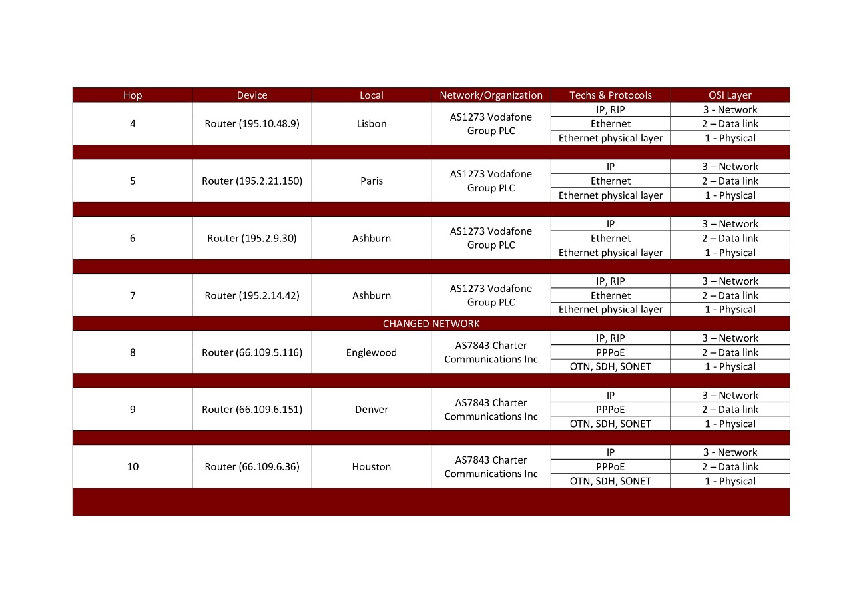

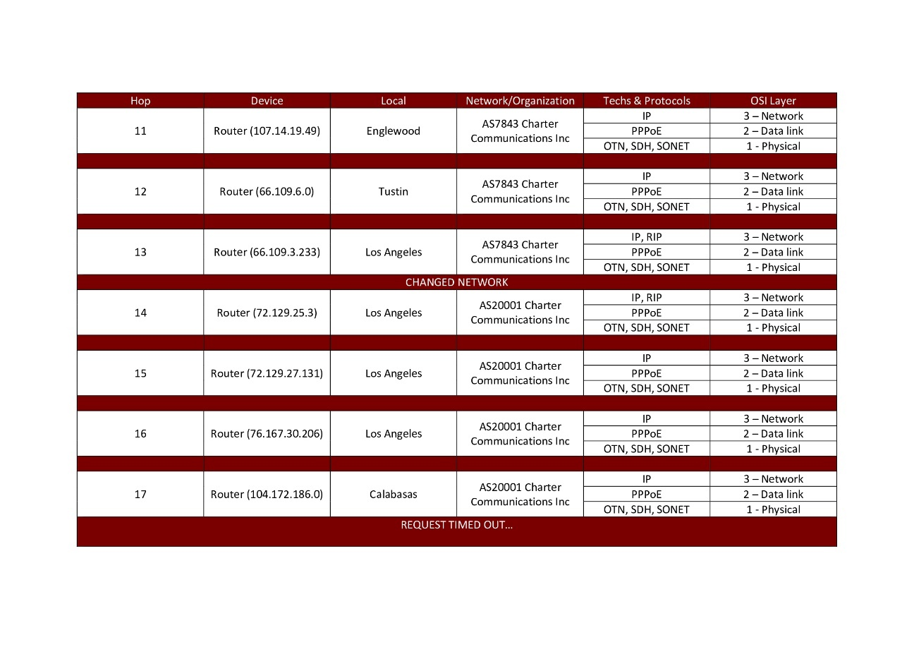

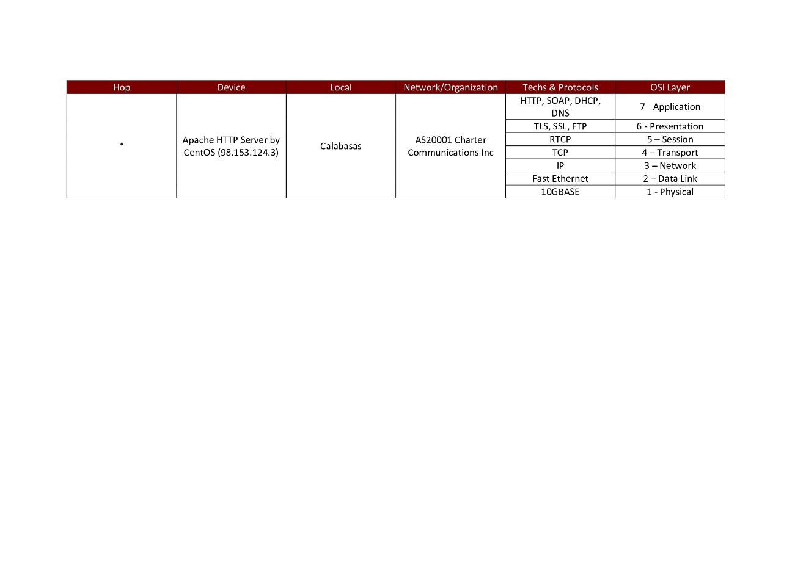

Apendix 2. Traceroute within UA Network

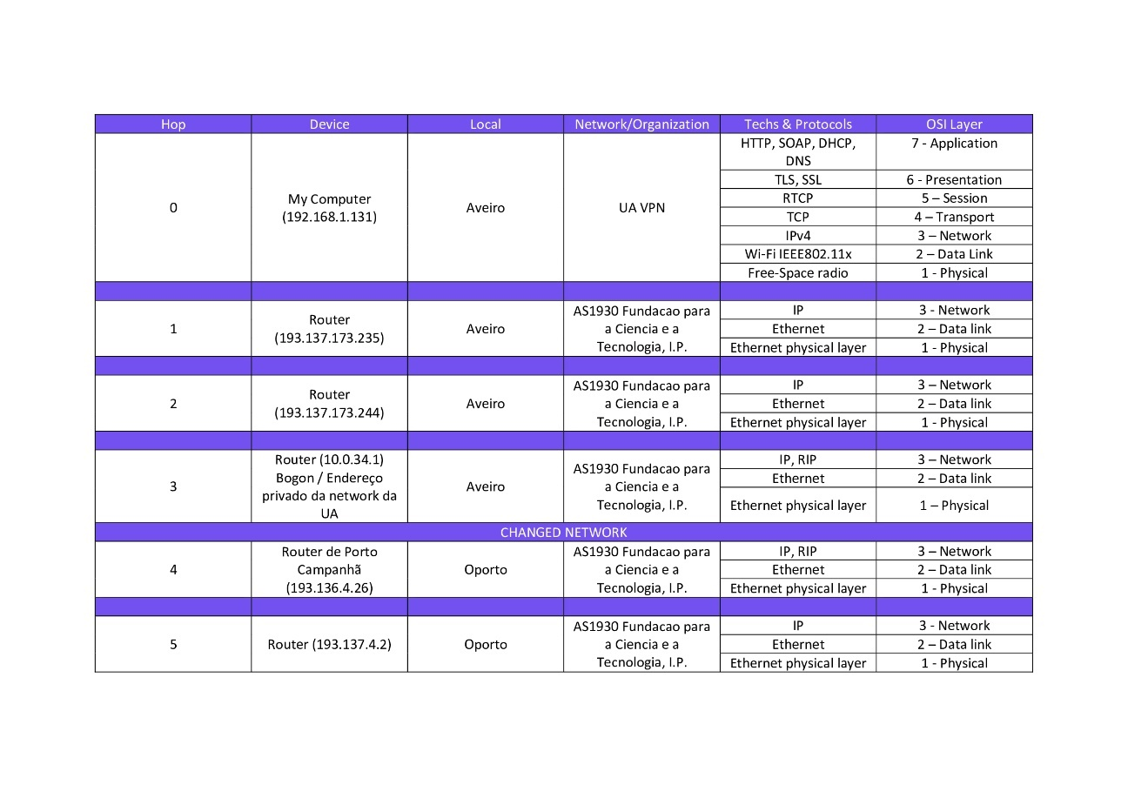

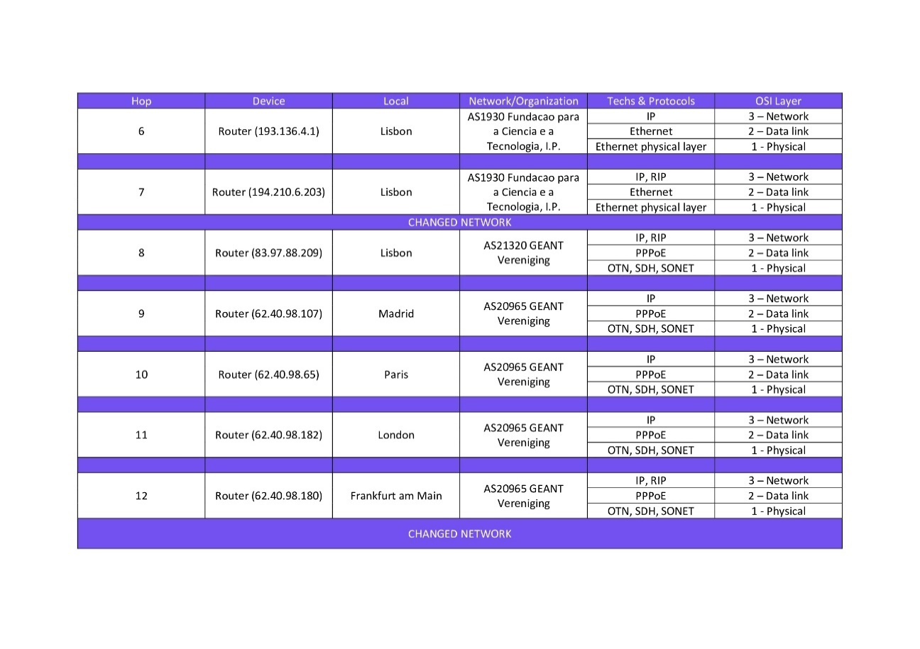

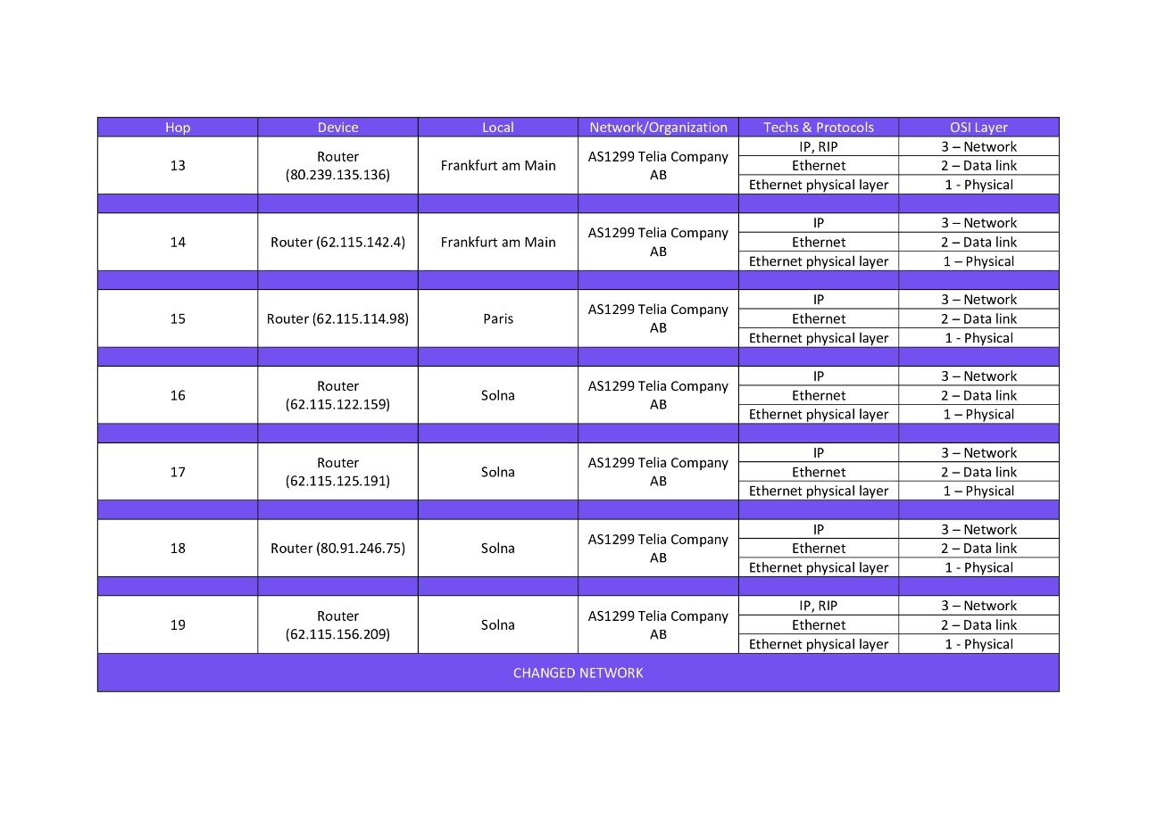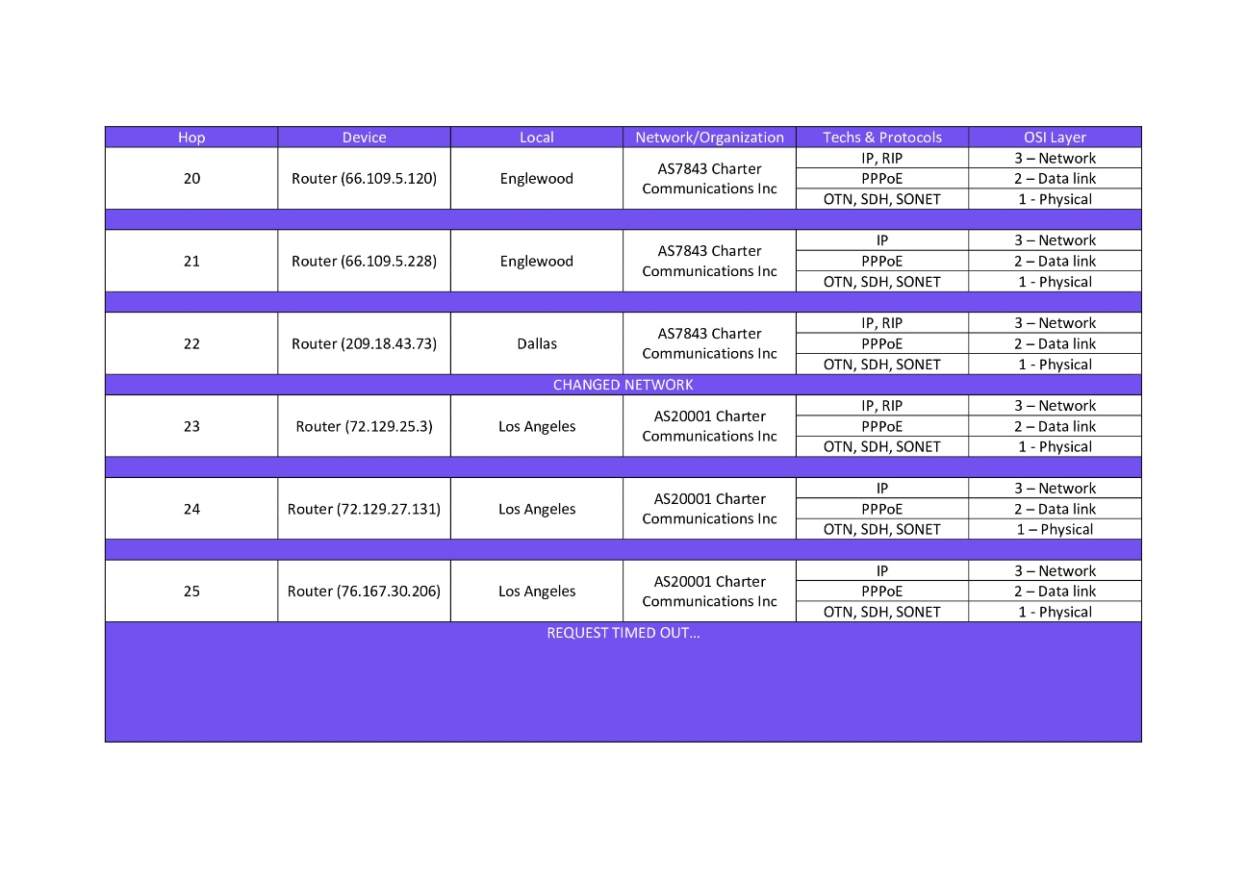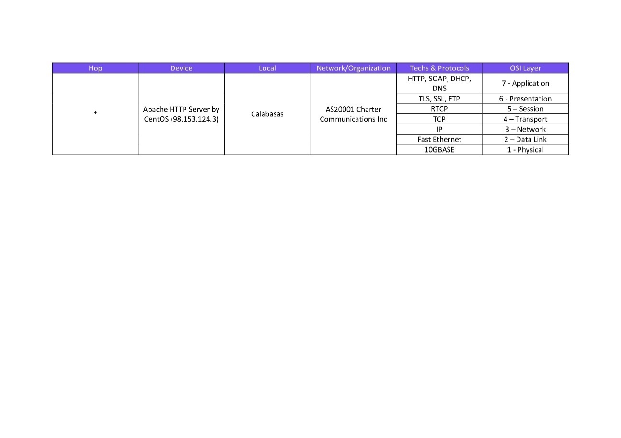

1. in this case, when talking about a network, I’m referring to the network of a specific ISP/organization that is connecting successively to larger ISPs, becoming part of their networks [13]
2. through the use of a NAP, in which two ISPs set up their POPs in order to allow connectivity between them [14]